Safeguard Your Infrastructure Against Fire & Thermal Disasters

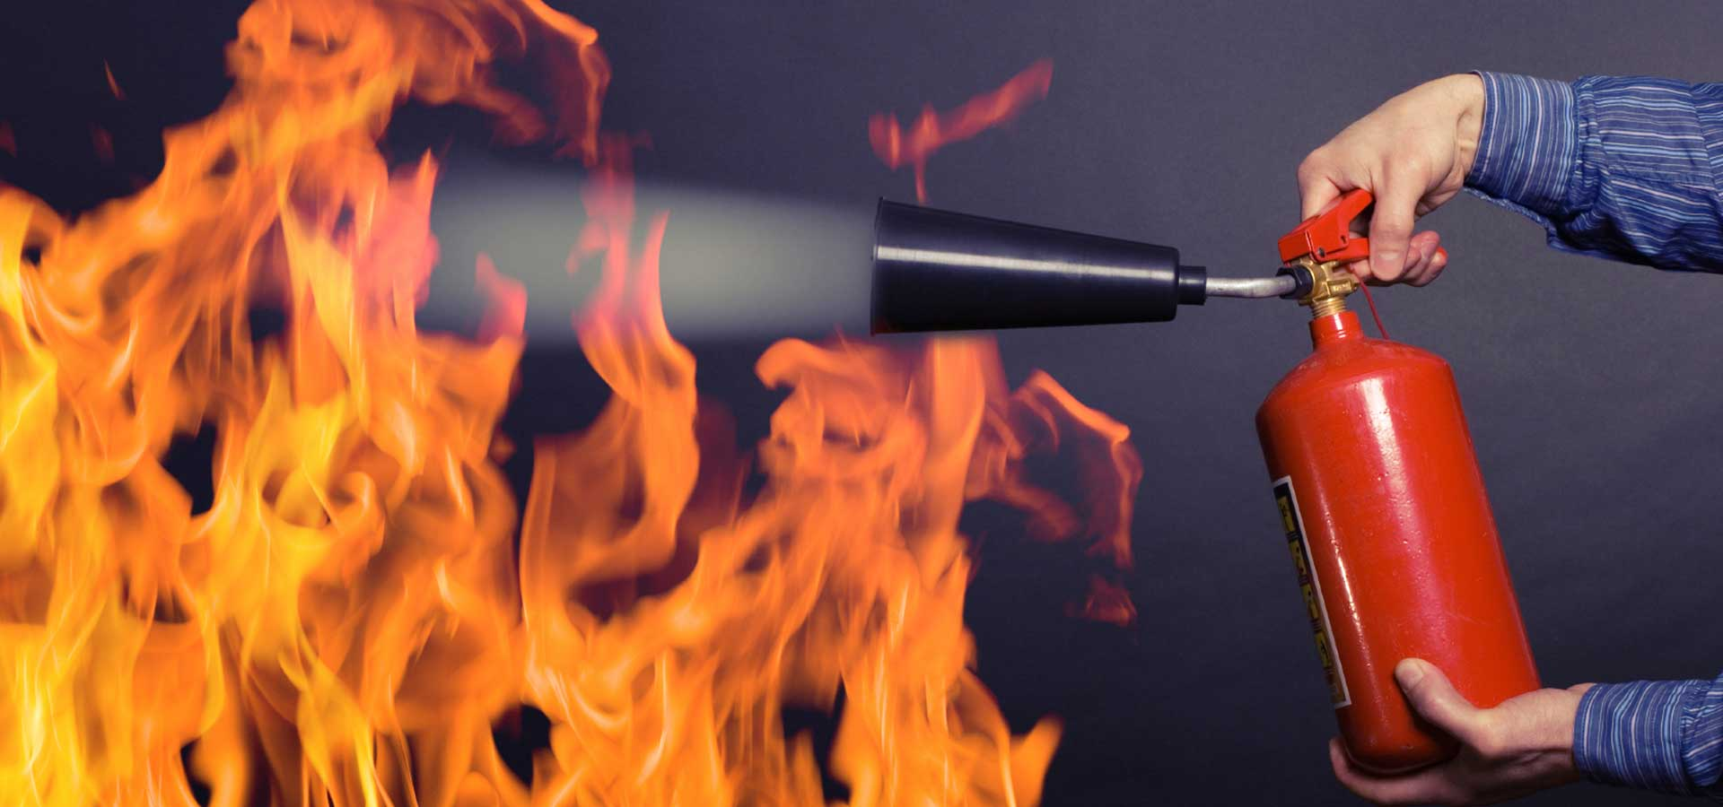
Importance of fire and heat detection systems
The world of business and commerce is constantly changing and evolving, and with that so are the dangers that we face on a daily basis. One of the most common and potentially lethal danger is fire. That’s why it is so important to have an effective fire and thermal safety solution in place.
There are many different types of fire and thermal safety solutions available on the market, such as fire alarm systems, fire suppression systems, smoke and heat detection systems, and much more. All of these solutions have their own advantages and disadvantages, so it’s important to choose the right one for your needs.
In this blog, we will take a look at the importance of fire and thermal safety solutions and some of the different types that are available.

Fire Alarm Systems and Its Components
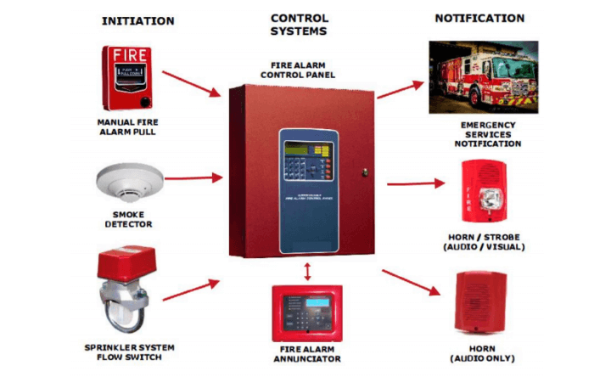
Fire alarm systems are an important part of any commercial or industrial building. They help in alerting the occupants from the dangers of fire and help them evacuate when there’s still time. Fire alarm systems come in many different types and configurations, but all systems have one common goal: to provide early warning of a fire so that occupants can evacuate the building safely.

There are many different types of fire alarm systems, but they all share some common components. These include Smoke detectors, which detect the presence of smoke in the air and activate the alarm; Heat detectors, which detect the presence of heat and also activate the alarm; and Fire alarm control panels, which receive signals from the detectors and activate the alarm and other systems that are set in place to suppress the fire.

Fire Suppression Systems
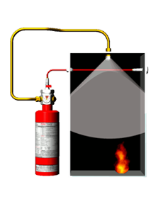
Fire suppression systems are another important part of a fire safety plan. These systems are designed to extinguish a fire in its early stages, before it has a chance to spread. There are two types of fire suppression systems namely manual and automatic. Manual fire suppression systems require someone to activate the system when they see or smell smoke. Automatic fire suppression systems are designed to detect a fire and activate the system without any human intervention.
Smoke and Heat Detection systems
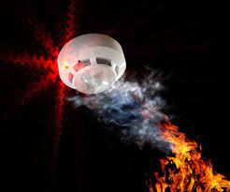
Smoke and heat detection systems are designed to detect a fire in its early stages and trigger the fire alarm system which in turn alerts the occupants of a building so that they can evacuate to a safe area. It consists of a sensor that detects the presence of smoke in the air and a temperature monitoring sensor which constantly keeps an eye on the ambient temperature of the space. Smoke and heat detection system automatically triggers the sprinkler system as a response, to help extinguish the fire as soon as possible. This could be very crucial in minimizing the damage and containing the fire and heat and restricting it from causing more damage.
Why go with Network Techlab?
Our team includes Fire Safety Engineers who determine the most suitable fire alarm system for your premises. They start by identifying your specific needs and the number of detectors that need to be installed on your premises. They also check if the fire alarm system is compatible with your current security system. Hence we are capable of suggesting the most suitable equipment system that fits within your budget without sacrificing quality.

To connect with us, feel free to call 8879004536 or send an email to info@netlabindia.com.

